1. What are variable length arguments in Java?
Variable-length arguments (varargs) allow you to pass a variable number of arguments to a method. Use ... after the data type in the method signature.

Example:
public class VarArgsExample {
public static void displayNumbers(int... numbers) {
for (int num : numbers) {
System.out.print(num + " ");
}
System.out.println();
}
public static void main(String[] args) {
displayNumbers(1, 2, 3); // Output: 1 2 3
displayNumbers(5); // Output: 5
displayNumbers(); // Output: (nothing)
}
}

Rules:
- Internally, varargs are treated as an array.
- Only one varargs parameter is allowed, and it must be the last parameter.

2. Can we replace arguments in main method with variable length arguments?
Yes, we can replace the arguments in the main method with variable-length arguments in Java.
The main method signature:
public static void main(String[] args)
can be replaced with:
public static void main(String... args)

Example:
public class VarArgsInMain {
public static void main(String... args) {
for (String arg : args) {
System.out.println(arg);
}
}
}

How It Works:
- Both String[] args and String... args are treated the same by the JVM.
- You can still run the program and pass command-line arguments like before.

Output:
For java VarArgsInMain Hello World:
Hello
World

3. There are two variables: int i = 9 and int i = 09, is there a difference between the two? Is int i = 09 a valid statement?
In Java, there is a difference between int i = 9; and int i = 09;.

Explanation:
- int i = 9;:
- This is a valid statement. i is assigned the value 9 as a decimal (base 10) number.
2. int i = 09;:
- This is not a valid statement in Java.
- In Java, a leading 0 indicates that the number is in octal (base 8) format.
- Octal numbers can only contain digits from 0 to 7. Therefore, 09 is not a valid octal number, and it will cause a compilation error like:
error: integer number too large

Correct Example for Octal:
int i = 011; // Valid octal number (9 in decimal)
In this case, 011 is an octal representation, which equals 9 in decimal.

4. What is a Base class?
A base class (also known as a superclass or parent class) in object-oriented programming is a class that provides common functionality or attributes that can be inherited by other classes (called derived classes or subclasses).
The base class acts as the foundation for creating more specialized classes.

Features:
- Inheritance: A subclass inherits fields and methods from the base class, enabling code reuse and reducing redundancy.
- Common Behavior: The base class usually contains common behavior (methods) and attributes (fields) that are shared among all subclasses.
- Not Always Instantiated: The base class itself is often not instantiated directly; instead, subclasses are instantiated, inheriting the properties and methods from the base class.

Example:
class Animal { // Base class
void eat() {
System.out.println("This animal eats food.");
}
}
class Dog extends Animal { // Derived class
void bark() {
System.out.println("The dog barks.");
}
}
public class Main {
public static void main(String[] args) {
Dog dog = new Dog();
dog.eat(); // Inherited from Animal (Base class)
dog.bark(); // Defined in Dog (Derived class)
}
}

Output:
This animal eats food.
The dog barks.
- The Animal class is the base class, and Dog is the derived class.
- The Dog class inherits the eat() method from the Animal class, making use of common functionality defined in the base class.

5. Difference between Abstract Class and Base Class?
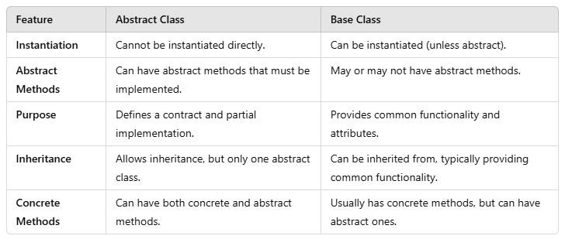

6. Difference between Abstract Class and Interface?
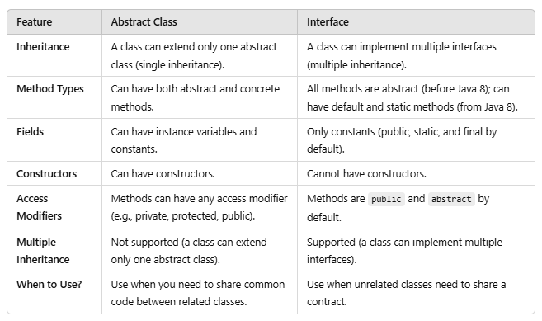

7. Difference between Abstract Class and Functional Interface?
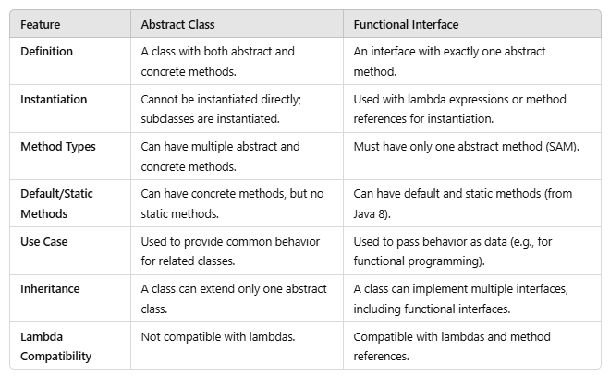

8. You have a Hashmap, which is overridden and the hashcode method is also overridden, so that it always returns a constant value, lets say, 1 . After adding multiple values to the hashmap, what will be the complexity of fetching a value from such hashmap.
When the hashCode() method is overridden to always return a constant value (e.g., 1), all keys will collide and be stored in the same bucket of the HashMap. As a result, the retrieval complexity is affected.

Fetching Complexity:
- In a normal HashMap, the average time complexity of fetching a value is O(1), as keys are usually well-distributed across buckets.
- When all keys collide (same hash code), the complexity depends on how the keys are stored in the bucket:
Pre-Java 8:
- The bucket uses a linked list. Searching for a key in this linked list takes O(n) time in the worst case, where n is the number of elements in the bucket.
Java 8 and later:
When the bucket size exceeds a threshold (typically 8), the linked list is converted to a balanced binary search tree (BST). In this case:
- Lookup in the BST takes O(log n).
- If the bucket size is below the threshold, it remains a linked list, and complexity remains O(n).

9. What is rehashing?
Rehashing is the process of resizing a HashMap and redistributing its entries when the load factor threshold is exceeded.
The default load factor is 0.75, and the initial capacity is 16. This helps maintain efficient retrieval and insertion operations.
- When: Rehashing occurs when the number of elements exceeds capacity × load factor.
- What happens: The capacity is doubled, and all elements are rehashed into the new bucket array.
- Time Complexity: The rehashing process takes O(n) for resizing, but ensures average O(1) complexity for subsequent operations.

Example in Code:
import java.util.HashMap;
public class Main {
public static void main(String[] args) {
// Initial capacity = 4, Load factor = 0.75
HashMap<Integer, String> map = new HashMap<>(4, 0.75f);
// Adding elements to trigger rehashing
map.put(1, "One");
map.put(2, "Two");
map.put(3, "Three");
map.put(4, "Four"); // Rehashing happens after this
System.out.println("HashMap after rehashing: " + map);
}
}

10. What are the criteria for Hashmap keys?
In Java, HashMap keys must satisfy below criteria to function correctly. These criteria ensure the keys are handled efficiently during storage and retrieval.

1. Keys Must Be Non-Null
- A HashMap allows a single null key.
- If you try to insert another null key, it will overwrite the existing entry.
Example:
HashMap<String, Integer> map = new HashMap<>();
map.put(null, 1); // Valid, adds a null key
map.put(null, 2); // Overwrites the previous null key entry
System.out.println(map); // Output: {null=2}

2. Keys Should Be Immutable
- The value of a key should not change after it’s inserted into the HashMap.
- If the key’s value changes (e.g., a mutable object like StringBuilder), it may not be retrievable because its hash code and equality comparison might differ.
Bad Example:
HashMap<StringBuilder, String> map = new HashMap<>();
StringBuilder key = new StringBuilder("key1");
map.put(key, "Value1");
key.append("Updated"); // Modifying the key
System.out.println(map.get(new StringBuilder("key1"))); // Output: null

3. Keys Must Implement equals() and hashCode() Consistently
- The hashCode() method determines the bucket where the key-value pair is stored.
- The equals() method is used to compare keys within the same bucket.
- Keys with the same hashCode() should also be equal according to the equals() method.
Example:
class Employee {
int id;
String name;
Employee(int id, String name) {
this.id = id;
this.name = name;
}
@Override
public int hashCode() {
return id; // Hash based on id
}
@Override
public boolean equals(Object o) {
if (this == o) return true;
if (o == null || getClass() != o.getClass()) return false;
Employee e = (Employee) o;
return id == e.id;
}
}
HashMap<Employee, String> map = new HashMap<>();
Employee emp1 = new Employee(1, "John");
Employee emp2 = new Employee(1, "Doe");
map.put(emp1, "Manager");
System.out.println(map.get(emp2)); // Output: Manager

11. Can String or String builder or primitive integer or wrapper class be a hashmap key?

1. String as a HashMap Key
- Allowed: String is one of the most commonly used types for HashMap keys.
- Why: Strings are immutable, meaning their state cannot change after creation. This ensures consistent behavior for hashCode() and equals().
- Example:
HashMap<String, String> map = new HashMap<>();
map.put("Key1", "Value1");
map.put("Key2", "Value2");
System.out.println(map.get("Key1")); // Output: Value1

2. StringBuilder as a HashMap Key
- Not Recommended: While technically possible, it’s risky.
- Why:StringBuilder is mutable, so its hashCode() and equals() can change if the object is modified. This can lead to unexpected behavior.
- Example of Issue:
HashMap<StringBuilder, String> map = new HashMap<>();
StringBuilder key = new StringBuilder("Key1");
map.put(key, "Value1");
key.append("Updated"); // Modifying the key
System.out.println(map.get(new StringBuilder("Key1"))); // Output: null

3. Primitive int as a HashMap Key
- Not Allowed: Primitive types cannot be used directly as keys because HashMap only accepts objects as keys.
- Alternative: Use the wrapper class Integer instead.

4. Wrapper Class (e.g., Integer) as a HashMap Key
- Allowed: Wrapper classes like Integer, Double, etc., are immutable and work well as keys.
- Why: They implement hashCode() and equals() correctly, ensuring consistent behavior in the HashMap.
- Example:
HashMap<Integer, String> map = new HashMap<>();
map.put(1, "One"); map.put(2, "Two");
System.out.println(map.get(1)); // Output: One

Summary:
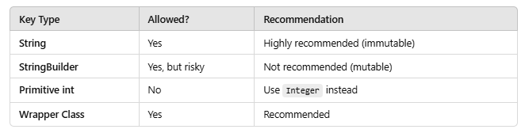

12. What is fail-fast and fail-safe in collections?
In Java, the behavior of iterators when a collection is structurally modified during iteration is categorized into fail-fast and fail-safe.

1. Fail-Fast Iterators
Behavior:
- These iterators throw a ConcurrentModificationException if the collection is structurally modified during iteration, except through the iterator itself.
- Fail-fast iterators directly access the collection’s internal structure. Any structural modification invalidates the iterator, ensuring data consistency.
Examples:ArrayList, HashMap, HashSet, etc.
Code Example:
import java.util.ArrayList;
public class FailFastExample {
public static void main(String[] args) {
ArrayList<Integer> list = new ArrayList<>();
list.add(1);
list.add(2);
list.add(3);
for (Integer num : list) {
System.out.println(num);
list.add(4); // Structural modification
}
}
}
Output:
1 Exception in thread "main" java.util.ConcurrentModificationException

2. Fail-Safe Iterators
Behavior:
- These iterators do not throw ConcurrentModificationException even if the collection is structurally modified during iteration.
- Fail-safe iterators operate on a copy of the collection, not the original, so modifications to the original collection do not affect iteration.
Examples:CopyOnWriteArrayList, ConcurrentHashMap.
Code Example:
import java.util.concurrent.CopyOnWriteArrayList;
public class FailSafeExample {
public static void main(String[] args) {
CopyOnWriteArrayList<Integer> list = new CopyOnWriteArrayList<>();
list.add(1);
list.add(2);
list.add(3);
for (Integer num : list) {
System.out.println(num);
list.add(4); // Structural modification allowed
}
System.out.println("List after iteration: " + list);
}
}
Output:
1 2 3 List after iteration: [1, 2, 3, 4, 4, 4]

Differences Between Fail-Fast and Fail-Safe
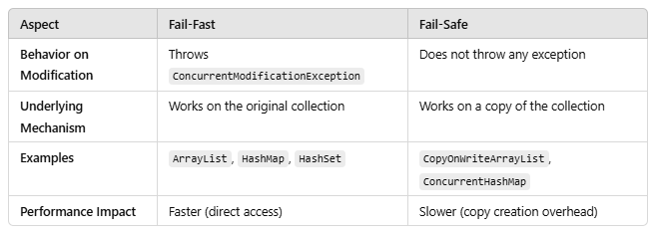

13. You have a string builder as a hashmap key, now you appended the string builder. What will be value of the string builder with the get object?
If you use a StringBuilder as a HashMap key and modify (append) the StringBuilder after adding it to the map, you may not be able to retrieve the value associated with that key. This is because the hashCode of StringBuilder depends on its current state, and modifying it changes the hashCode.

Explanation:
- StringBuilder as a Key:
- The hashCode() of a StringBuilder is calculated based on its current content.
- If you modify the StringBuilder, the hashCode() changes, and the HashMap can no longer locate the key in its internal structure.
2. Effect on Retrieval:
- After modification, the key becomes “untraceable” since the HashMap uses the hashCode to find the bucket where the key-value pair is stored.

Code Example:
import java.util.HashMap;
public class HashMapStringBuilderKey {
public static void main(String[] args) {
HashMap<StringBuilder, String> map = new HashMap<>();
StringBuilder key = new StringBuilder("Key1");
map.put(key, "Value1");
System.out.println("Before modification: " + map.get(key)); // Output: Value1
// Modify the StringBuilder
key.append("Modified");
System.out.println("After modification: " + map.get(key)); // Output: null
}
}

Output:
Before modification: Value1
After modification: null

Solution:
- Use immutable keys like String instead of StringBuilder.
HashMap<String, String> map = new HashMap<>();
String key = "Key1";
map.put(key, "Value1"); key = key + "Modified"; // No impact on map
System.out.println(map.get("Key1")); // Output: Value1
2. Avoid modifying objects used as keys in a HashMap.

14. There are two variables, storing exchange rates of currency. Now, what data type will you use for these variables and which method will you use to equate them?
When dealing with exchange rates of currencies, it’s essential to ensure precision due to the potential for financial inaccuracies caused by floating-point arithmetic.

Data Type for Exchange Rates
- Use BigDecimal in Java for storing exchange rates.
- Reason: BigDecimal provides high precision and control over rounding behavior, making it ideal for financial calculations.
- Why not float or double: Floating-point numbers (float and double) can introduce rounding errors due to their binary representation, which is unsuitable for financial computations.

Method for Equating Exchange Rates
- To compare two BigDecimal variables, you can use the compareTo() method instead of equals().
- Reason: The equals() method checks for both value and scale (e.g., 1.0 is not equal to 1.00), whereas compareTo() only compares the numerical value.

Example:
import java.math.BigDecimal;
public class CurrencyExchange {
public static void main(String[] args) {
BigDecimal rate1 = new BigDecimal("74.256");
BigDecimal rate2 = new BigDecimal("74.2560");
// Comparing using compareTo()
if (rate1.compareTo(rate2) == 0) {
System.out.println("Exchange rates are equal.");
} else {
System.out.println("Exchange rates are different.");
}
}
}

15. How long does Heap memory and Stack Memory stay in Java?

Heap Memory Lifecycle:
- Persists as long as the object is referenced or until garbage collection removes it.
- Exists for the entire lifetime of the JVM instance.

Stack Memory Lifecycle:
- Exists only during the execution of a method.
- Destroyed when the method finishes or the thread terminates.

16. What is Marker interface in Java? Can we create a custom Marker interface?
- A marker interface is an interface with no methods or fields (essentially empty).
- It is used to indicate or “mark” a class for a specific capability, behavior, or property.

Examples:
- Serializable: Marks a class as serializable, enabling object serialization.
- Cloneable: Marks a class as cloneable, allowing its objects to be cloned.
- Remote: Marks a class as remote for distributed computing.

Purpose:
- They act as a tag to signal to the JVM or frameworks that special behavior should be applied to marked classes.
- The marker is often checked using the instanceof operator or reflection.

Example:
public class Example implements Serializable {
// JVM allows serialization because this class is marked as Serializable
}

Custom Marker Interface?
Yes, you can create your own marker interface. It can be used to signal a specific behavior or functionality in your application.

Example:
// Custom Marker Interface
public interface MyMarker {}
// Class implementing the marker
public class MyClass implements MyMarker {}
// Checking the marker
public class MarkerTest {
public static void main(String[] args) {
MyClass obj = new MyClass();
if (obj instanceof MyMarker) {
System.out.println("Object is marked with MyMarker!");
} else {
System.out.println("Object is not marked.");
}
}
}

Usecase:
- When you need to define a custom tagging mechanism for specific types of classes.
- When frameworks or tools you create need to apply special logic to marked classes.
However, modern alternatives like annotations (e.g., @Override, @Deprecated) are often preferred for such use cases as they are more flexible and provide metadata directly.

17. You have an array list of Employees having Emp Id and Manager id. Retrieve data of all employees reporting to Manager with Emp Id = 200.
import java.util.*;
import java.util.stream.Collectors;
class Employee {
private int empId;
private int managerId;
// Constructor
public Employee(int empId, int managerId) {
this.empId = empId;
this.managerId = managerId;
}
// Getters
public int getEmpId() {
return empId;
}
public int getManagerId() {
return managerId;
}
@Override
public String toString() {
return "Employee{empId=" + empId + ", managerId=" + managerId + '}';
}
}
public class ManagerEmployeeFilter {
public static void main(String[] args) {
// Sample Employee List
List<Employee> employees = Arrays.asList(
new Employee(101, 200),
new Employee(102, 200),
new Employee(103, 201),
new Employee(104, 200),
new Employee(105, 202)
);
// Manager ID to filter by
int managerId = 200;
// Filtering employees who report to the manager with EmpId = 200
List<Employee> reportingEmployees = employees.stream()
.filter(emp -> emp.getManagerId() == managerId)
.collect(Collectors.toList());
// Check if the list is empty or contains employees
if (reportingEmployees.isEmpty()) {
System.out.println("No employees found reporting to Manager with EmpId = " + managerId);
} else {
System.out.println("Employees reporting to Manager with EmpId = " + managerId + ":");
reportingEmployees.forEach(System.out::println);
}
}
}

Explanation:
- Data Filtering:
- filter(emp -> emp.getManagerId() == managerId) ensures we only retrieve employees whose managerId is 200.
2. Check for Empty List:
- If reportingEmployees.isEmpty() evaluates to true, it prints a message indicating no employees were found.

18. What is a Circuit breaker pattern?
This is a very important question that came up in both my first and second rounds at Capgemini.
In a microservices architecture, a Circuit Breaker is a design pattern used to detect failures in a system and prevent them from propagating to other parts of the system. It helps in improving the system’s resilience by allowing the system to recover from failures gracefully. The main goal is to prevent a system from repeatedly making calls to a service that is failing and causing additional load or cascading failures.

Circuit Breaker Working:
- Closed State:
- In the closed state, the circuit breaker allows all requests to go through to the service.
- If the service responds successfully, everything continues as normal.
- If the service fails a number of times (typically due to timeouts or exceptions), the circuit breaker moves to the open state.
2. Open State:
- When the failure threshold is exceeded, the circuit breaker “opens” and all requests are rejected.
- During this time, instead of making the request, the circuit breaker returns a fallback response or performs other recovery mechanisms.
- After a certain “cooldown” period, the circuit breaker will move to the half-open state.
3. Half-Open State:
- In the half-open state, the circuit breaker allows a limited number of requests to pass through to check if the issue is resolved.
- If the service is working fine, the circuit breaker goes back to the closed state.
- If the service is still failing, the circuit breaker goes back to the open state.

Components of Circuit Breaker:
- Failure Threshold: The number of failures after which the circuit breaker will open.
- Timeouts: Time window after which the circuit breaker switches back from the open to the half-open state.
- Fallback Mechanism: In case of failure, a fallback response can be provided, such as cached data or default values.

Advantages of Circuit Breaker:
- Prevents cascading failures: By stopping the flow of requests to a failing service, you prevent further damage or system overload.
- Improves resilience: The system can recover more gracefully by falling back to alternative paths.
- Better resource management: The system avoids overloading failing services and uses resources more efficiently.

19. How do you do fault isolation?
Fault isolation is the process of identifying, diagnosing, and containing errors or faults in a system to prevent them from affecting other parts of the system.
It ensures that failures are handled gracefully and do not propagate or impact other services or components.
Here’s how fault isolation can be achieved:

1. Exception Handling:
- Use robust exception handling mechanisms to capture errors and prevent crashes.
- Properly define custom exceptions where needed to better categorize different fault scenarios.

2. Try-Catch Blocks (Error Containment):
- Wrap critical sections of code that are prone to errors in try-catch blocks to catch exceptions and handle them appropriately, such as logging them or notifying the user.

3. Circuit Breaker Pattern:
- Implement a circuit breaker to detect and isolate failures in external services or systems.
- If a particular service or external resource is failing repeatedly, the circuit breaker will stop further calls to it, preventing cascading failures.

4. Redundancy:
- Use redundancy in systems to isolate faults. For example, in databases, replication can help isolate faults and ensure availability even if one instance fails.
- Backup systems and load balancers can help ensure that failure in one part of the system does not bring down the entire system.

5. Microservices Architecture:
- In a microservices architecture, each service is isolated from others, and failures in one service don’t necessarily impact others.
- Implementing proper service boundaries and API gateways can further isolate faults within specific services.

6. Failover Mechanism:
- A failover mechanism allows a backup system or server to take over automatically when a primary system fails, ensuring minimal impact on system performance.

7. Log Aggregation and Monitoring:
- Set up log aggregation tools (e.g., ELK stack, Splunk) to monitor application logs in real-time. This helps in quickly identifying when something goes wrong, even before it fully impacts the system.
- Continuous monitoring tools (e.g., Prometheus, Grafana) help track the system’s health and allow for proactive fault isolation.

8. Distributed Tracing:
- Use distributed tracing (e.g., OpenTracing, Zipkin) to track requests across services and pinpoint where failures occur in a distributed environment.

9. Isolation at the Network Level:
- In distributed systems, ensure services can be isolated at the network level, where faulty services can be isolated by routing or network partitioning, preventing broader system impacts.

10. Resource Limits:
- Set resource limits (e.g., memory, CPU) to prevent a single faulty process from consuming all system resources and affecting other parts of the application.

11. Automated Testing:
- Perform thorough unit, integration, and regression testing to catch errors during development, preventing bugs from reaching production environments.

12. Containerization and Virtualization:
- Use containers (e.g., Docker) or virtual machines to isolate environments. If a container or VM fails, it can be restarted without affecting the rest of the system.

